Lab 10

Git and Git hub

**Step 01:**

**Install Git**: Downloaded and installed the Git from [git-scm.com](https://git-scm.com/downloads), then set up my username and email in the terminal with git config --global user.name "Chudarathnamani L" and git config --global user.email "chudarathnamanil.btdip23@rvu.edu.in".

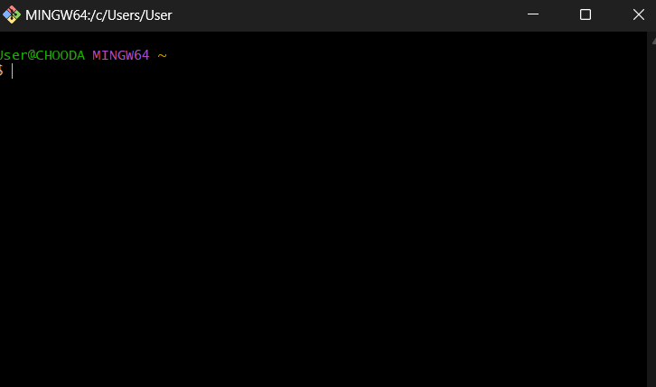

**Set Up GitHub**: Created my account at [GitHub](https://github.com/), created a new repository, and copied its URL.

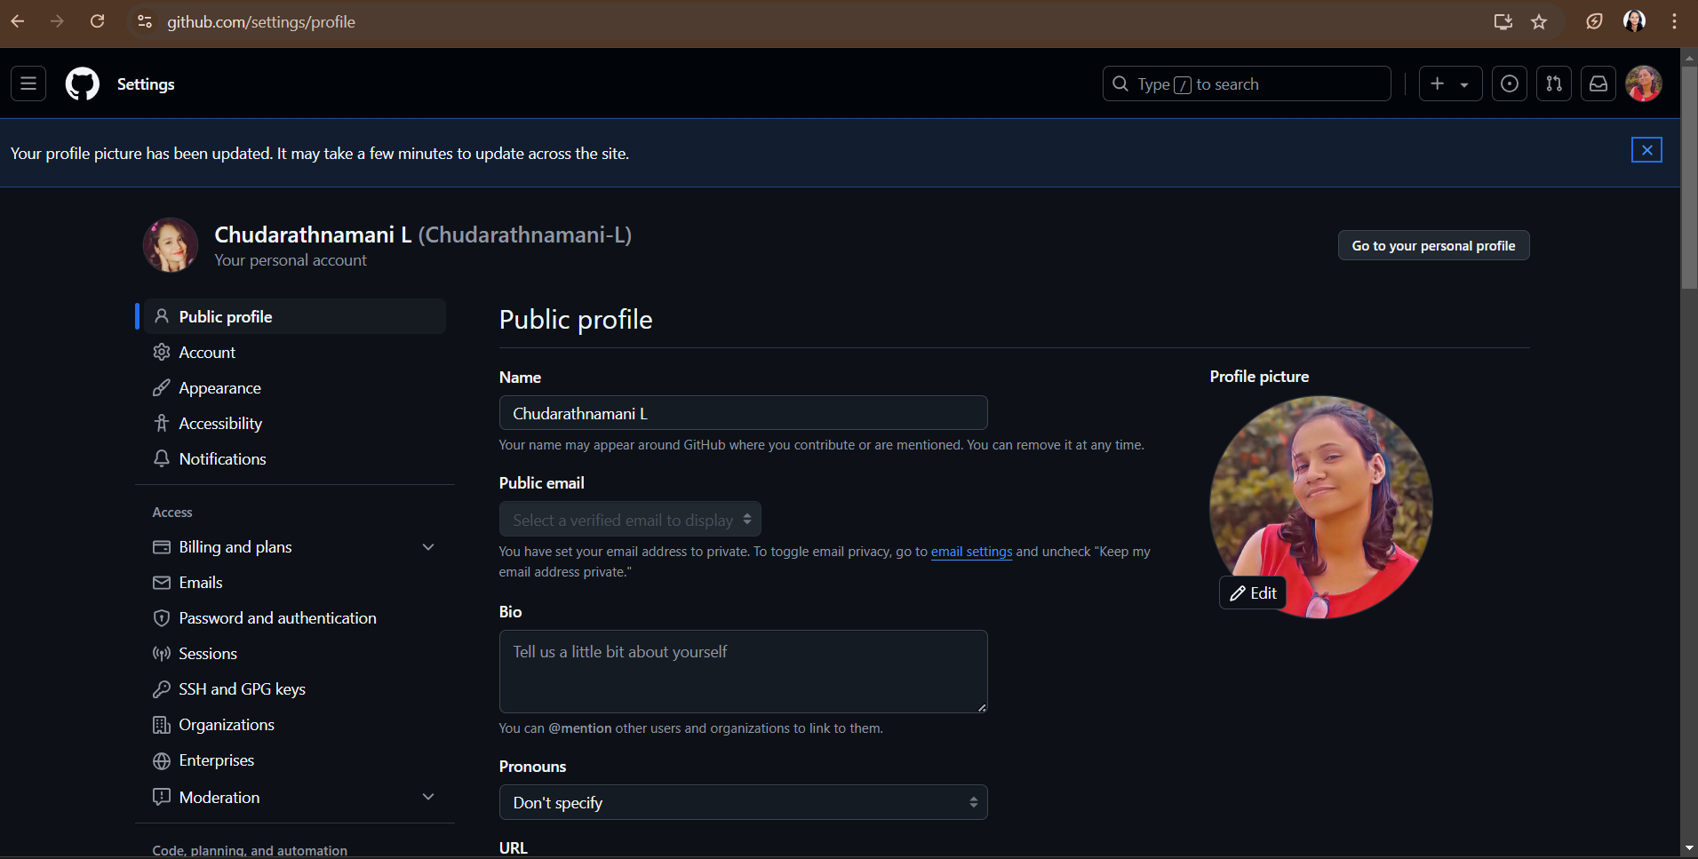

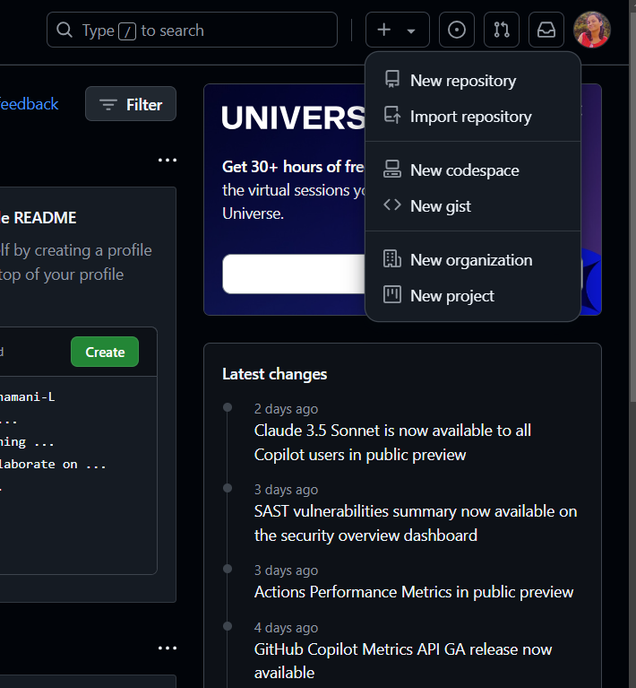

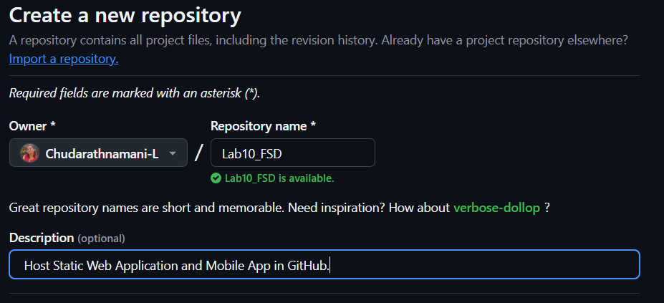

**Push Your Project**: Initialized Git in my project folder (git init), added files (git add .), committed (git commit -m "Initial commit"), connected to the GitHub repository (git remote add origin URL), and pushed (git push -u origin main).

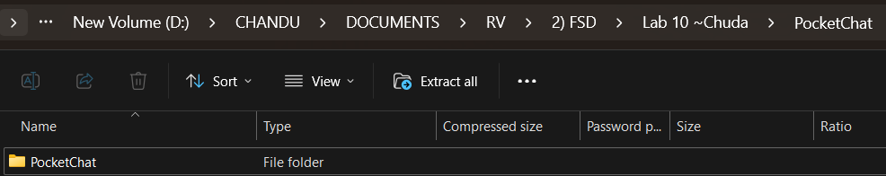

**Host on GitHub Pages** (for web apps): In my GitHub repo, gone to **Settings > Pages**, set the source to the main branch, and saved.